Analysis Results

von Mises Stress
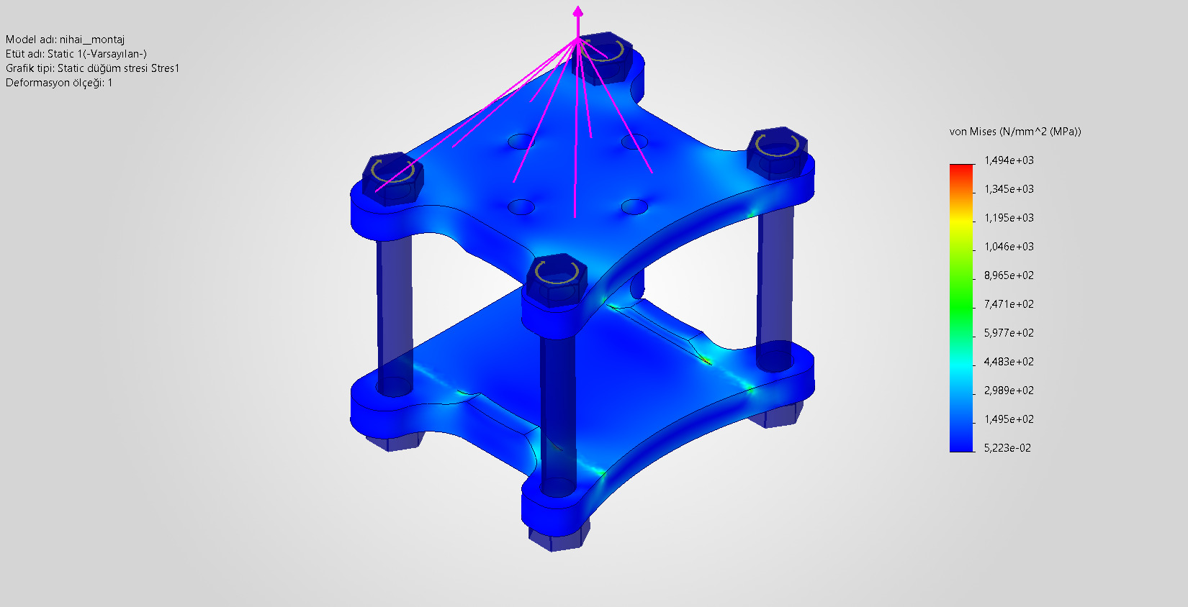

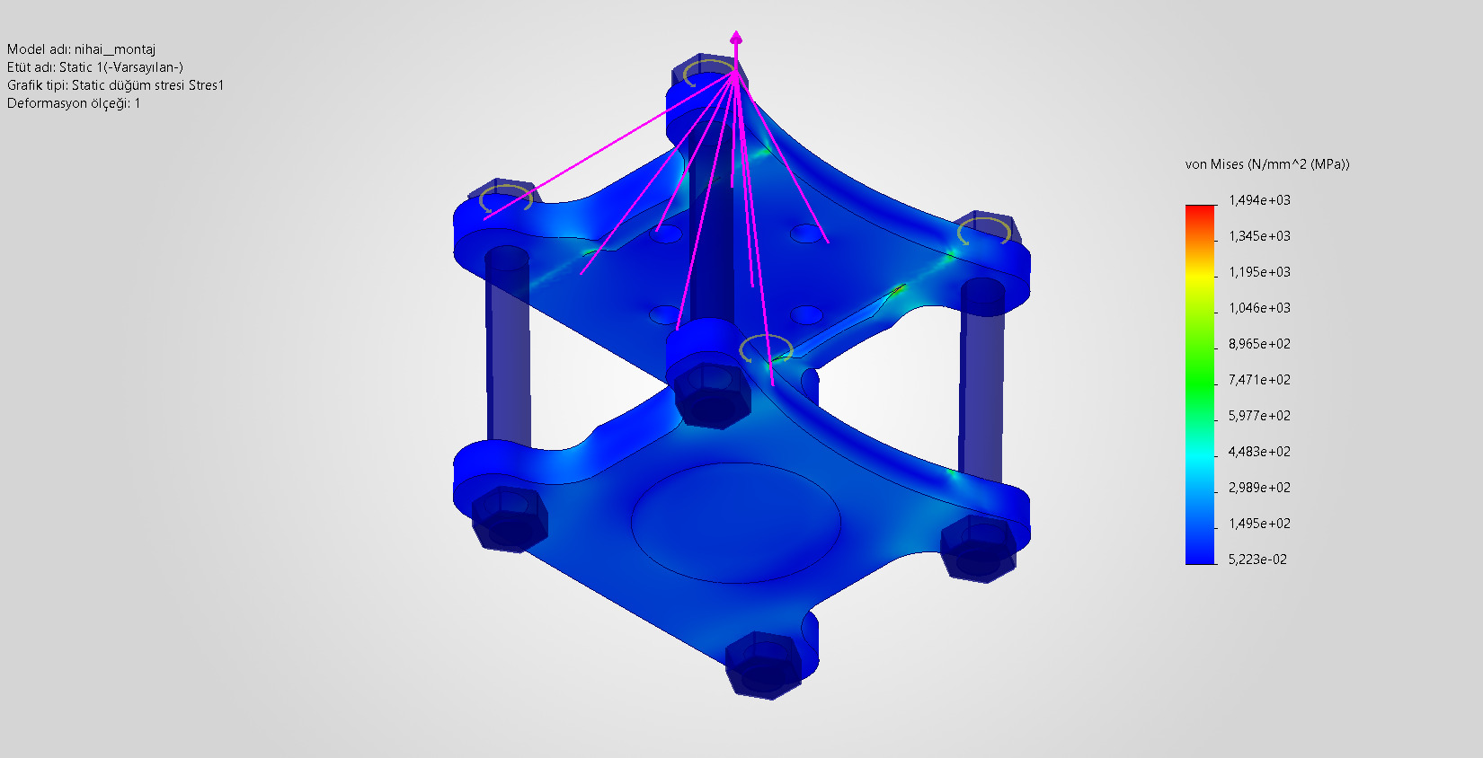
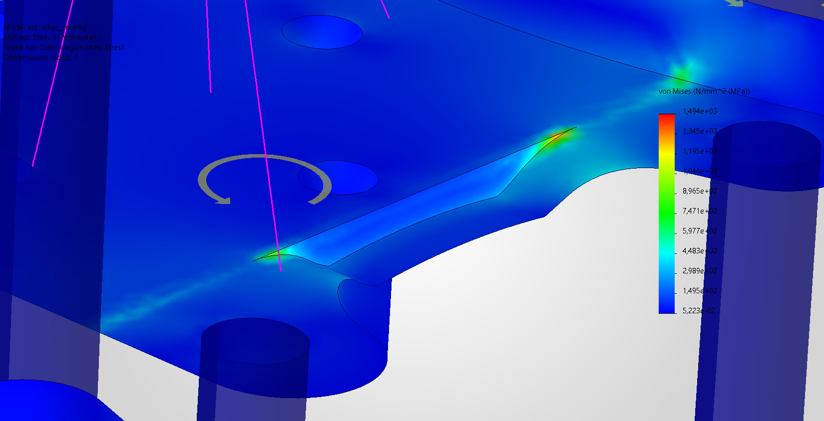
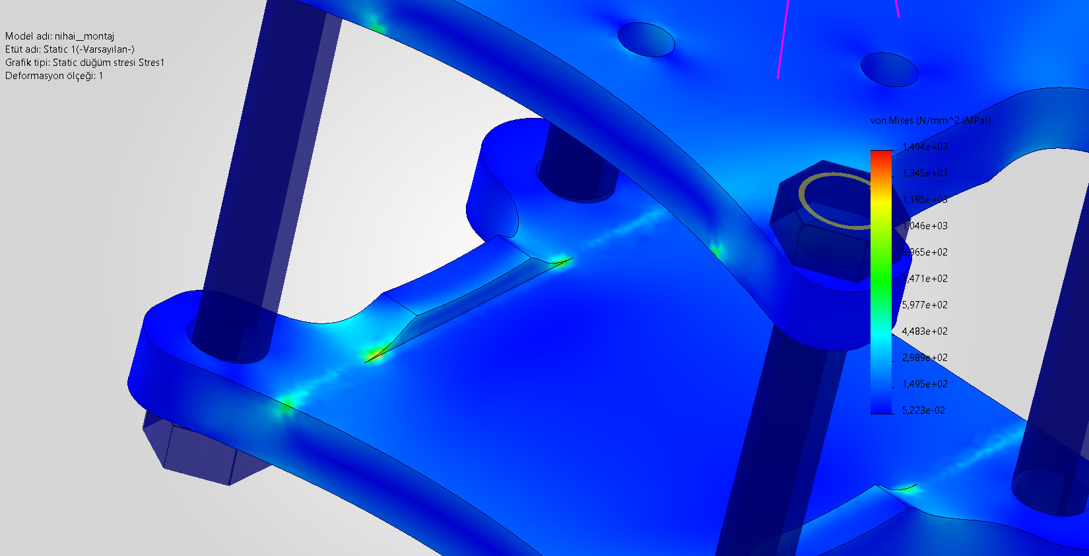

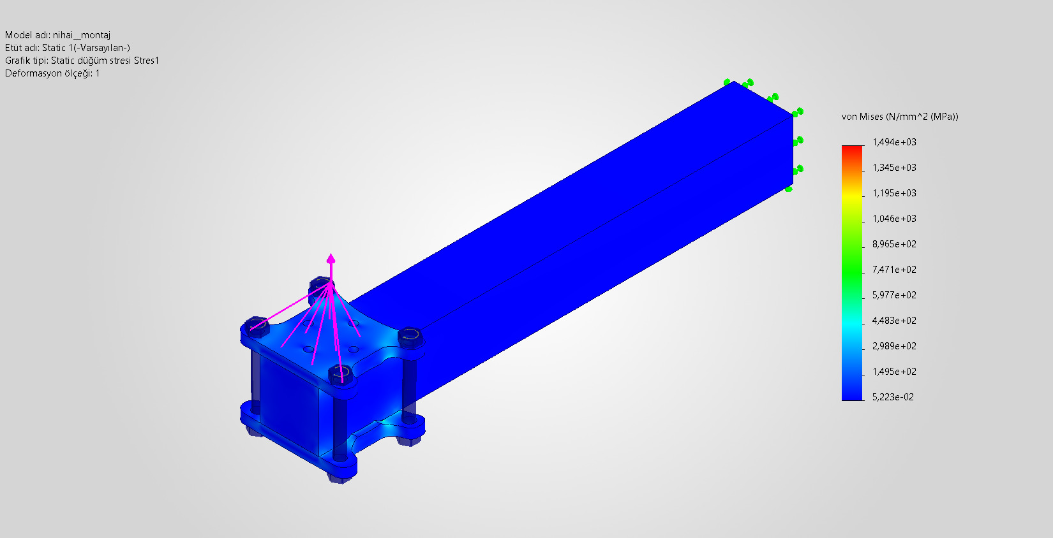

Total Displacement
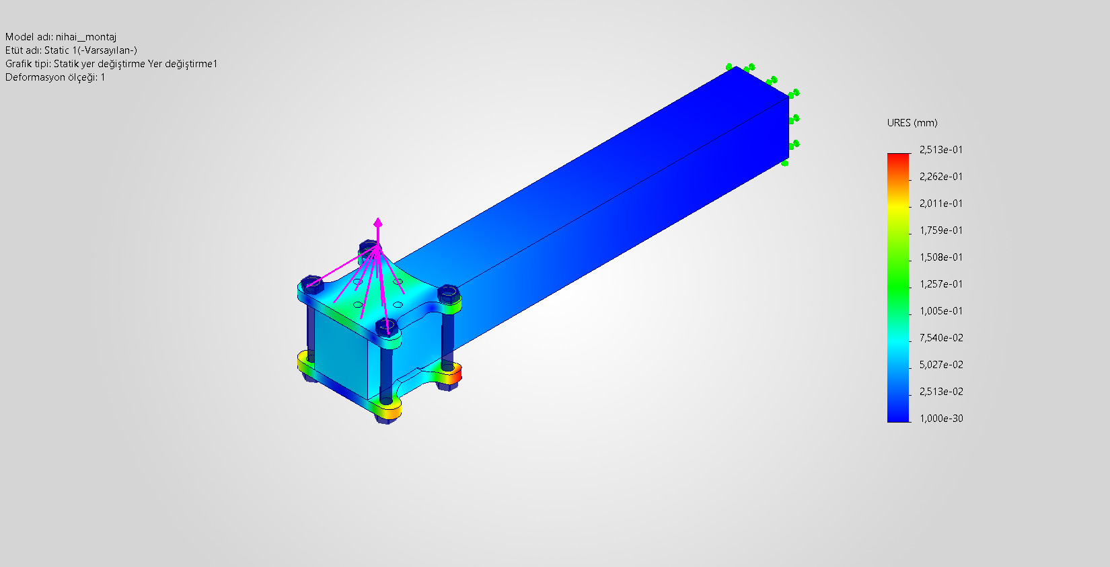

Analysis and Manufacturing Considerations: The FEA results revealed mathematical stress singularities and localized stress concentrations at the inner corners of the side supports. However, since the part will be manufactured using a three-axis CNC milling process, the natural fillet radius left by the cutting tool (end mill) will smooth these sharp corners and eliminate the unrealistic stress concentration observed in the simulation. Therefore, the design was intentionally retained in its current form and considered ready for manufacturing. Under the maximum thrust load case (LC-002), the maximum resultant displacement (URES) value of 0.25 mm confirms that the motor mount possesses high structural stiffness and provides sufficient structural integrity to prevent vibration-induced stability issues (commonly referred to as the "jello effect") during flight.

